**One-Way Ride**

**Shubh Ravishankar Gawhade**

**BA (Hons.) Game Design and Production, 2022-23**

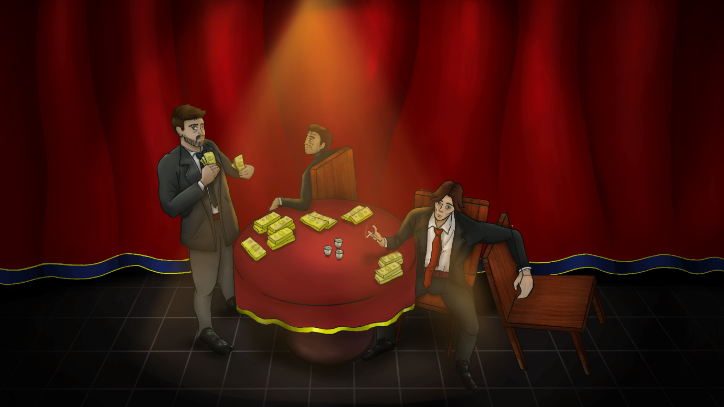

**Figure 1: Concept Art**

**School of Design and Informatics**

**Abertay University**

**Contents**

Abstract 4

1. Introduction 5

2. Research Context 6

2.1 How can we design puzzles around key story events and give players enough freedom without making it a handheld experience? 6

2.2 Does a unique gameplay experience in each chapter of the story add to the novelty of the experience? 7

2.3 How can you alter player experience based on their prior interactions without changing the overarching narrative? 9

2.4 How to create a fail state for stories central to the gameplay? 11

3. Research project : One-Way Ride 12

3.1 Creating Engaging Puzzles for Story-Driven Games 12

3.2 How Chapter-Based Gameplay Enhances Novelty 15

3.3 Tailoring Player Experience to Prior Interactions within a Fixed Narrative 17

3.4 Creating Fail States for Story-Driven Games 17

4. Conclusion 19

References 20

**List of Figures**

Figure 1: Concept Art 1

Figure 2: States a player can transition into 7

Figure 3: Keeping the player in the flow channel. 7

Figure 4: A Branching Story Graph 9

Figure 5: Using an Experience Manager to compute trajectories through State Space. 10

Figure 6: Exploration in Disco Elysium 12

Figure 7: Exploration in One-Way Ride (WIP) 13

Figure 8: Interactable Objects are outlined in different colours 14

Figure 9: Interaction is not visible as the player has a low intelligence level. 14

Figure 10: Player can interact with the Receptionist after gaining information. 15

Figure 11: The multiple level fading system with each floor having their own trigger. 16

Figure 12: Shooting enemies from behind cover Interactables. 16

# **Abstract**

One-Way Ride is a design research project that aims to create a story-driven 3D top-down hybrid game prototype with multiple genres of playstyles. The project addresses four research questions related to designing puzzles, creating unique game-play experiences, altering player experiences based on interactions, and creating fail states for stories. Research findings and different methods to solve the problem from various literary, game, and development sources are presented, along with the decisions taken during the project after analysing what was feasible and best for the prototype. The research project report ends with what went right, the challenges faced, and things to take away from the experience.

# **1. Introduction**

My project is to make a story-driven indie game prototype that combines 3D top-down gameplay with multiple genres of play-styles. The game idea is heavily inspired by other games like What Remains of Edith Finch, Disco Elysium and the Mafia Series which are known for their immersive storytelling, rich characters, and diverse gameplay mechanics. The aim of this design research project is to explore the interplay between narrative and game design by implementing interactive gameplay around a pre-determined narrative and creating “narrative puzzles” for our game prototype.

This topic is interesting for design research because it explores the unique challenge of designing puzzles around key story events and how each chapter has a different play-style on top of the 3D interaction and exploration system which drives the overall story and it explores how different play-styles can affect the player’s perception and emotional connection with the characters and the world.

The key research questions which arise are:

- How can we design puzzles around key story events and give players enough freedom without making it a handheld experience?

- Does a unique gameplay experience in each chapter of the story add to the novelty of the experience?

- How can you alter player experience based on their prior interactions without changing the overarching narrative?

- How to create a fail state for stories central to the gameplay?

The research method is practice-based and informed by literature review. The literature review consists of analysing game design sources such as books, articles, and GDC talks that are relevant to the game concept and genre. The research is embedded within the process of design and development of the game prototype, which is a playable demo that showcases the core gameplay features and narrative elements of the game. The prototype is built on the Unity game engine and uses C# as the programming language.

The results from this research will contribute to the field of game design by providing insights into how to create compelling puzzles that integrate with the story and enhance the player experience. The findings will also inform the further development and improvement of the game prototype.

# **2. Research Context**

## **2.1 How can we design puzzles around key story events and give players enough freedom without making it a handheld experience?**

To understand how to design puzzles, we must first understand what a puzzle is. A puzzle is a problem which challenges the player to test their knowledge about the situation. In a puzzle, the solver is expected to put pieces together (or take them apart) in a logical way, to arrive at a conclusion and complete a task. There are three types of puzzles, internal logic, where the puzzles are based on the game’s rules and setting, designer logic, where the puzzles are arbitrary and confusing and lock and key, where the puzzles have one fixed solution that can be solved in multiple ways [1].

Clara Fernández-Vara, an expert in adventure game analysis points out that puzzles in adventure games are frequently integrated into the narrative events, and the game story is advanced through puzzle solving, she further defines these types of puzzles as “narrative puzzles” [2]. According to a paper by Wei Huaxin and Betty Durango [3], narrative puzzles are distinct design elements that play a role in the unfolding, and the player’s experience of the game plot. They review other previous literature on puzzles and identify four main functions that narrative puzzles can perform for game storytelling: preparation and acquisition, advancement and guidance, creating plot variation, and pacing and structuring.

***Preparation and acquisition:*** This function involves puzzles that help the player acquire narrative information or in-game items that are useful for future puzzles. They may not have an obvious solution or goal, but they provide short-term aesthetic experiences and introduce the player to the game world, functions, and its logic.

***Advancement and guidance:*** This function involves puzzles that move the game plot forward and guide the player to the next plot segment. They are often integrated into the narrative events and require the player to interact with objects or characters in the game world. They may also unlock clues or objectives that show the player where to go next. [4]

***Creating plot variation:*** This function involves puzzles that have the potential to change plot trajectories and create different outcomes based on the player’s performance. These puzzles are often embedded with crucial plot points or branching points, where the player’s actions and choices can lead to different consequences or endings. They can also enhance the player’s agency and engagement with the game narrative.

***Pacing and structuring:*** This function involves puzzles that help pace the plot and gameplay along the game progression. These puzzles can align the level of difficulty or complexity with the narrative arc to create dramatic tension or rhythm. They can also serve as narrative units that organize the game plot into segments or chapters. These puzzles can improve the player’s comprehension and immersion in the game narrative.

The paper concludes that puzzles in narrative games are not only a gameplay mechanic but also a storytelling device that can enrich the game’s plot and the player’s experience.

Some common mistakes when designing puzzles include making them too difficult or easy, not providing enough feedback to the player, and not considering the player’s perspective when designing the puzzle.

## **2.2 Does a unique gameplay experience in each chapter of the story add to the novelty of the experience?**

Gameplay experience is a complex and multidimensional phenomenon that emerges from the interaction between a game and a player. In The Art of Game Design [5], Jesse Schell talks about how people experience games by focusing and in a way getting lost in the world of the game and describes this state of sustained focus, pleasure, and enjoyment is referred to as “flow,” which has been the subject of extensive study by psychologist Mihalyi Csikszentmihalyi and many others. The key components to put the player in a state of flow are clear goals, no distractions, direct feedback, and challenges. Flow activities must manage to stay in the narrow margin of challenge that lies between boredom and frustration, for both unpleasant extremes cause our mind to change its focus to a new activity.

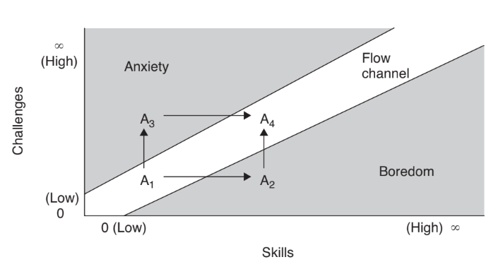

**Figure 2: States a player can transition into**

This means that the players focus keeps changing based on the challenges faced. The game must keep the player engaged to stay in the flow channel. The Diagram below shows the state which will probably feel much more interesting to a player. It is a repeating cycle of increasing challenge, followed by a reward, often of more power, which gives an easier period of less challenge.

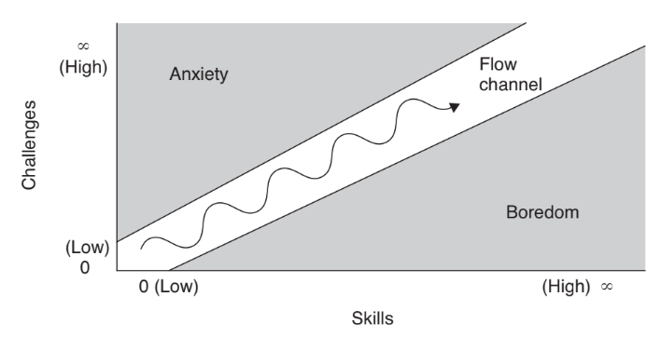

**Figure 3: Keeping the player in the flow channel.**

Researchers can interpret the paper Fundamental Components of the Gameplay Experience [6] and conclude that immersion is one of the key components of gameplay experience and it can be divided into three types: sensory, challenge-based and imaginative immersion.

Sensory immersion is related to the audio-visual execution of games, challenge-based immersion is related to the goals and tasks of games, and imaginative immersion is related to the characters, story and fantasy of games.

What Remains of Edith Finch (hereafter WRoEF) is a great example to showcase storytelling with different experiences by allowing the player to play a part in the life of each character which feels like a new experience and makes the story more engaging. As stated in the article by Mona Bozdog and Dayna Galloway [7], “The game is structured as a collection of short stories within a larger story. Each story is distinct and belongs to a different genre, using different storytelling techniques. The game’s overall structure borrows from the literary technique of a frame narrative by developing a collection of stories within a story within a story”.

WRoEF has a unique gameplay experience because it uses different interaction schemes and genres for each of its characters. It adapts literary structures, forms, techniques, and intertextuality to tell the stories of the Finch family members and their tragic deaths. It also uses text and voice-over narration aesthetically and playfully, making them “alive” and “endowed with personality”. The text also “functions as a visual and aural link to the past”.

## **2.3 How can you alter player experience based on their prior interactions without changing the overarching narrative?**

One of the key challenges in creating interactive narrative systems is how to balance user agency with coherent story progression. In “Interactive Narrative: An Intelligent Systems Approach” (2012) [8], the authors have suggested different ways to tackle this challenge, such as using plot graphs, experience managers, and player modelling.

A plot graph is a representation of a story where nodes represent narrative events and arcs denote precedence constraints. This means that no event can occur unless all events constrained to occur prior to it have already occurred.

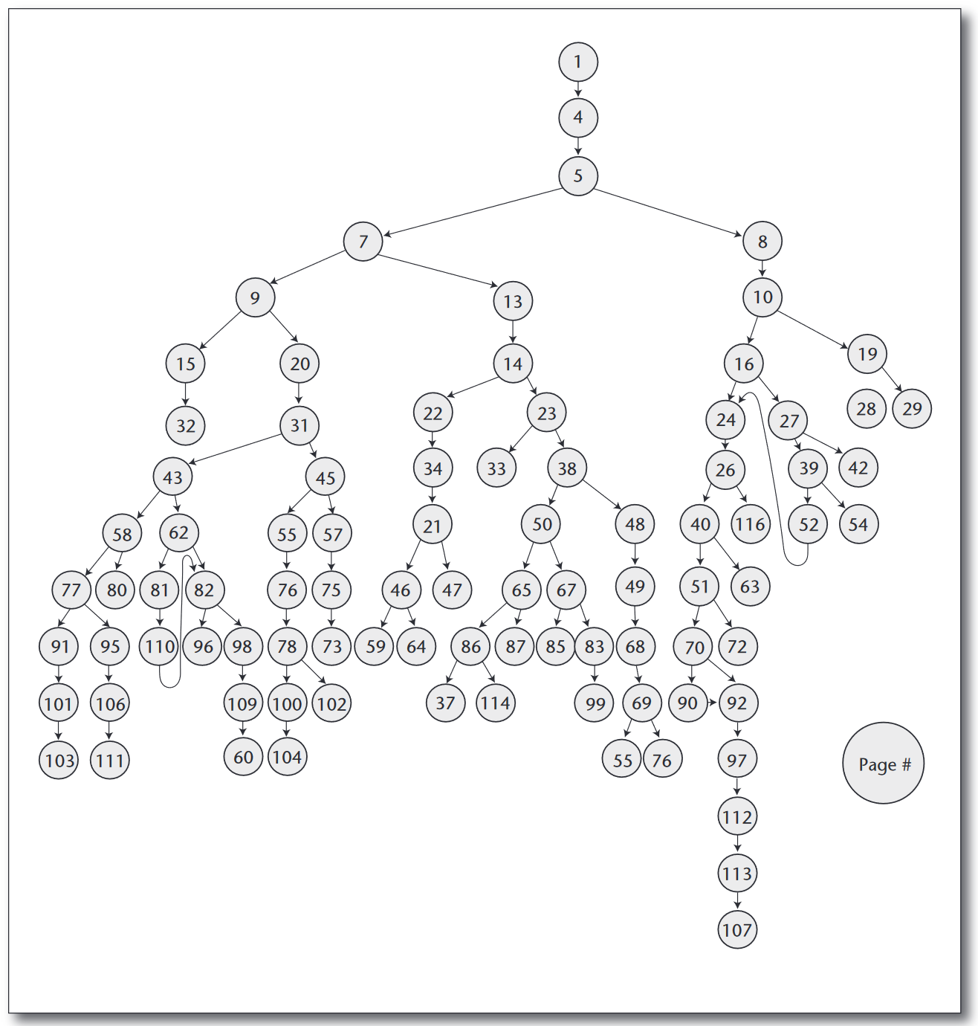

**Figure 4: A Branching Story Graph**

Some events are experience manager actions that can be performed at any time to increase the probability that certain trajectories occur. A search process generates possible trajectories, including experience manager actions, and evaluates the trajectories according to an author-defined heuristic. An experience manager is an artificial narrow intelligence agent that monitors the virtual world and intervenes to drive the narrative forward according to some model of quality of experience. The experience manager must look ahead into possible futures of the user’s experience to determine the best intervention, if any, to bring about a structurally coherent experience. The experience manager must also reason about the effects of its interventions in the virtual world to bring about the desired narrative experience.

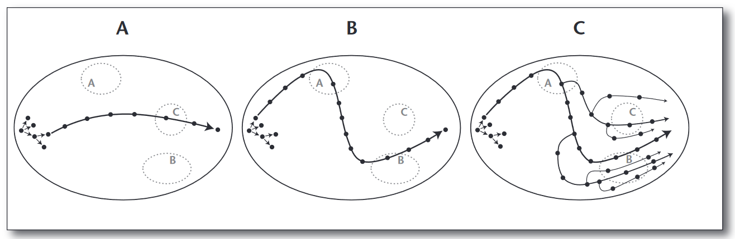

**Figure 5: Using an Experience Manager to compute trajectories through State Space.**

Player modelling involves learning a model of the user’s individual differences, such as preferences and play style, to tailor the narrative experience to the user. This can be done by mapping observed player behaviour in the fiction world into abstractions or by eliciting structured feedback from users across many interactive narrative experiences. [9]

The article also discusses the importance of incorporating believable characters into an interactive narrative framework. Believable characters are virtual agents that exhibit personality and emotion as they interact with the environment and the user. There can be a tension between an experience manager, which is trying to bring about a global structure to the user’s interactive experience, and virtual characters, which are attempting to perform local actions that promote believability.

Adaptive difficulty changes the game’s difficulty level based on how well the player is doing. For instance, the game can make things harder or easier by changing the number of enemies, the number of resources, or the type of obstacles. This way, the player can enjoy a balanced and engaging gameplay that is close to their skill level and preferences. [10]

Another method is branching paths, which lets the player make choices that have an impact on the game state or other characters. For example, the player can help or hurt a certain NPC and face different results, such as unlocking a new area, gaining, or losing an ally, or triggering a reward or a trap. This way, the player can see different outcomes and consequences based on their actions and decisions. [11]

The last method is dynamic content, which creates or changes the game’s content based on what the player does or likes. For example, the game can add more secrets, collectables, or easter eggs for the player to discover if they like to explore every corner of the game world. The manager can also generate more challenging or varied enemies for the player to fight off if they like to combat every enemy. The game can also provide more options or feedback for the player to customize their character or equipment if they like to do so. This way, the player can have a personalized and tailored game play that matches their interests and style.

## **2.4 How to create a fail state for stories central to the gameplay?**

A fail state is a situation where the player cannot progress or achieve the desired outcome in a game, and has to either restart or quit. A fail state can be used to create tension, challenge, feedback, or consequences for the player’s actions. However, a fail state can also be frustrating, boring, or unfair if not designed well. There are different degrees of punishment for failing, such as losing time, progress, or resources.

After reading The Hierarchy of fail states in game design [12], we understand that creating a fail state for stories central to the gameplay is a matter of balancing the severity and frequency of the punishment for failing and making it interesting and meaningful for the player. Some possible ways to do this are:

Using checkpoints or quick saves to preserve the player’s state and progress and allow them to retry the section they failed without losing too much time or resources.

Using different degrees of failure depending on the situation, such as losing some resources, having to restart a level, or losing all progress. The big question about the fail state is: What’s lost and can it be recovered? In roguelikes, again, you lose everything when you die. For games aimed at more casual players, failing will usually mean repeating the section or level.

Using fail states that are unpredictable or creative to add variety and humour to the gameplay, such as having loose controls, ragdoll physics, or unexpected consequences.

Using fail states that are relevant to the story or theme of the game, such as having different endings, branching paths, or character development depending on the player’s choices and actions.

Some examples of games that use fail states for stories in interesting ways are:

Heavy Rain: A cinematic adventure game where the player controls four characters who are involved in a serial killer case. The game has multiple endings and branches depending on the player’s choices and actions. If a character dies, the game does not end but continues with the other characters. [13]

Undertale: A role-playing game where the player can choose to befriend or fight monsters. The game has different endings and dialogues depending on the player’s actions and morality. If the player dies, they can restart from their last save point, but some characters will remember their previous deaths. [14]

Papers, please: A simulation game where the player works as an immigration officer in a fictional dystopian country. The game has multiple endings and storylines depending on the player’s decisions and performance. If the player makes too many mistakes or breaks the rules, they can be arrested, fired, or killed. [15]

# **3. Research project : One-Way Ride**

In this section, I will present the findings of my design project which is influenced by elements from “What Remains of Edith Finch” [16], “Disco Elysium” [17] and the “Mafia Series” [18] to create a unique and engaging experience for the players. One-Way Ride is a hybrid game prototype that combines 3D top-down with multiple playstyles. I am experimenting with the application of game systems and mechanics as to how the narrative and game design will work in tandem with each other. The game prototype is unique in the sense of how each chapter has its own playstyle on top of the 3D interaction and exploration system that drives the overall story. The narrative introduces new playstyles, for example, gun combat, stealth, and a combination of various game mechanics.

The game prototype was developed using Unity and C#. The narrative is broken down into five chapters with each chapter being broken down into its own missions and objectives that not only make sense of the world in which the game takes place but also make sense of the game’s genre and combination of playstyles. The prototype consists of the first 2 chapters which are:

• Chapter 1: The Whacking

• Chapter 2: Green Bills and Goons

We will go through the various design choices made, why the choices were made and what went right or wrong with respect to the research questions.

## **3.1 Creating Engaging Puzzles for Story-Driven Games**

> ***Player Movement:*** One-Way Ride implements a 3D top-down camera angle with click-to-move mechanics for the player, Mariano. This design choice was inspired by Disco Elysium, a role-playing game whose gameplay is focused on exploration, dialogue, and decision-making.

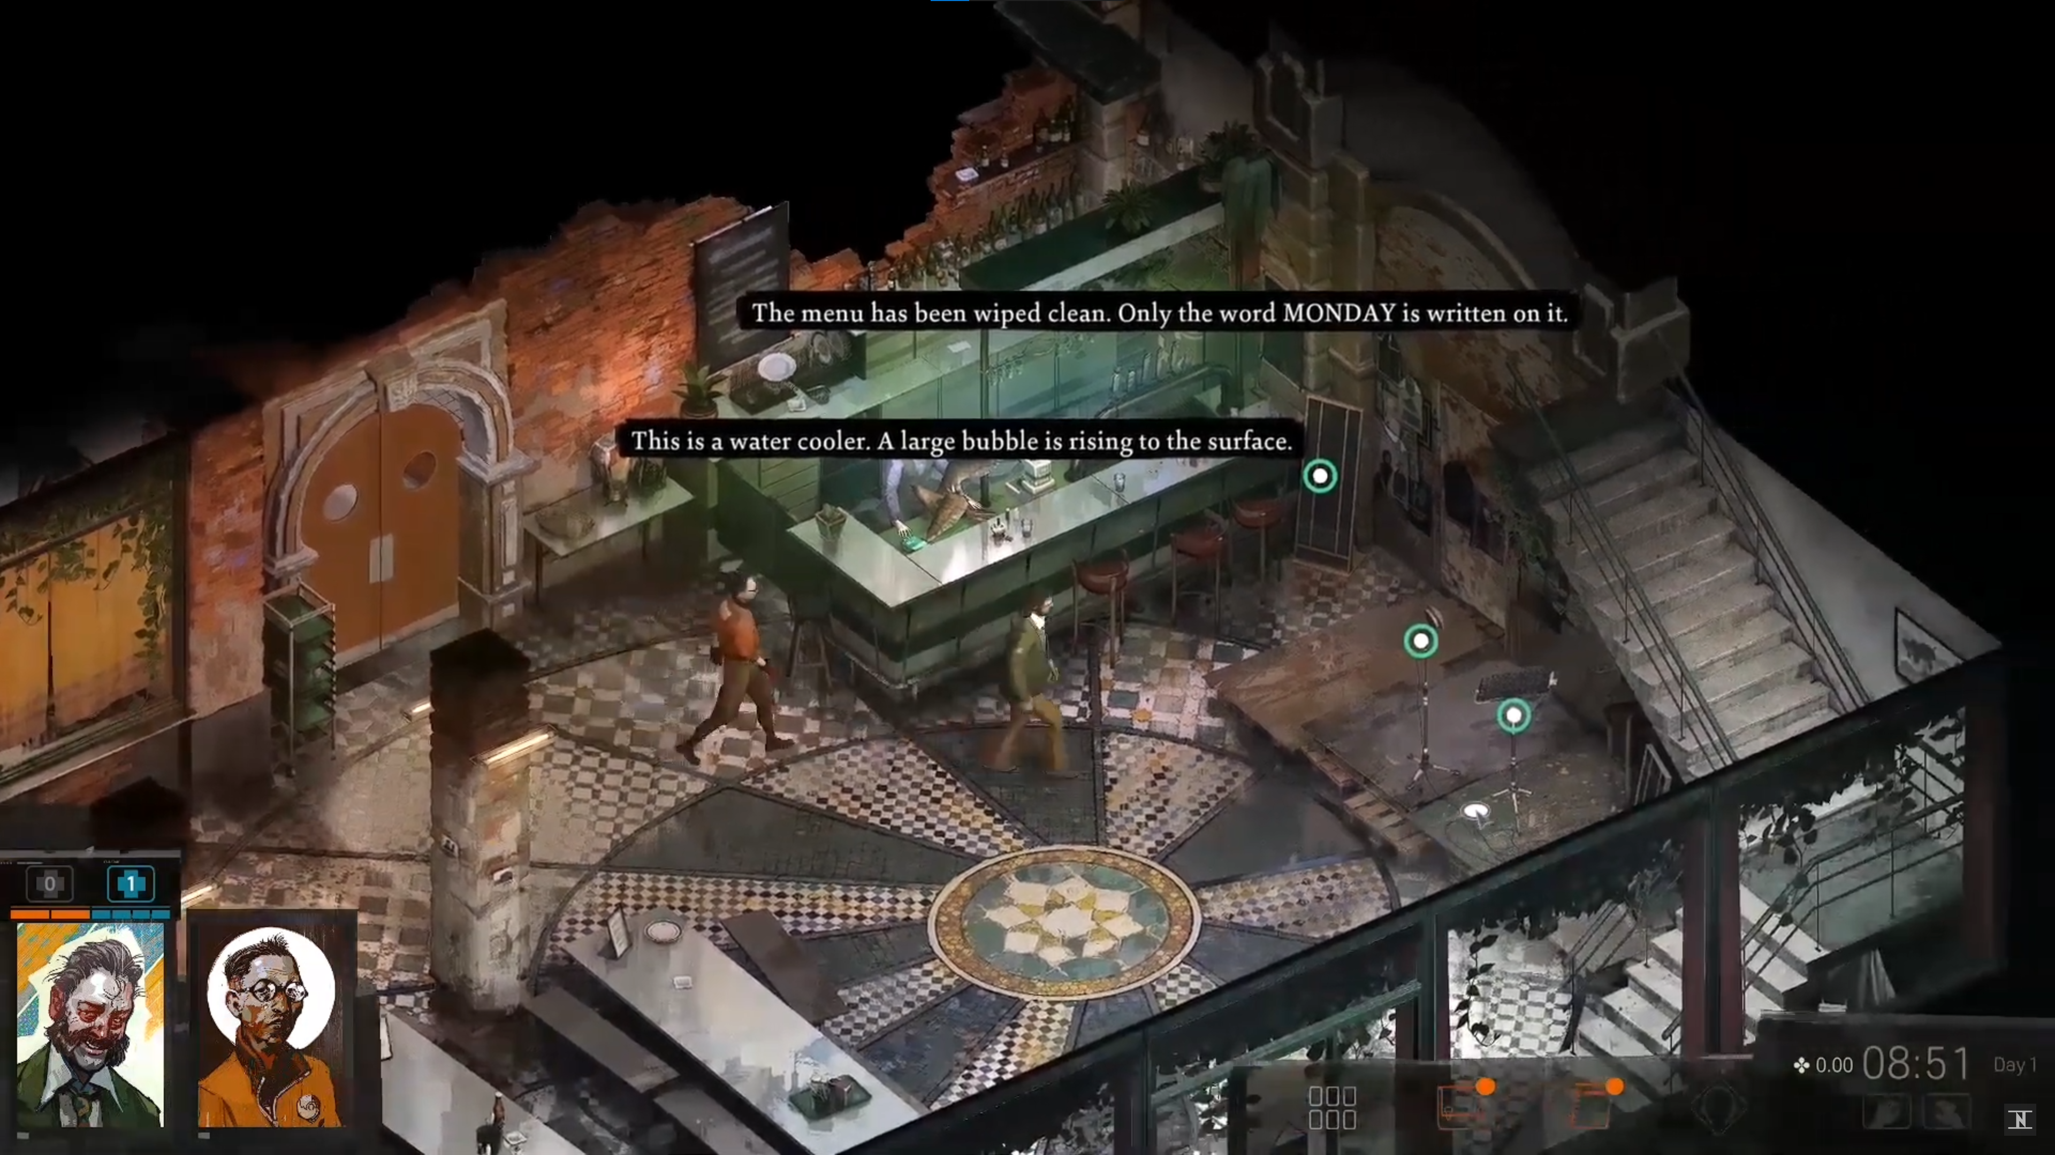

**Figure 6: Exploration in Disco Elysium**

Being a 3D top-down game, exploration is key. The character walks to the location the player clicks and runs when double-clicked, allowing the player to explore the environment and interact with objects and characters by simply clicking on them. Click-to-move is implemented because it allows the player to focus more on the story and the interactions, rather than on the mechanics and the interface. It also makes the game more accessible and intuitive for players who are not familiar with complex controls or who prefer a more casual gameplay experience.

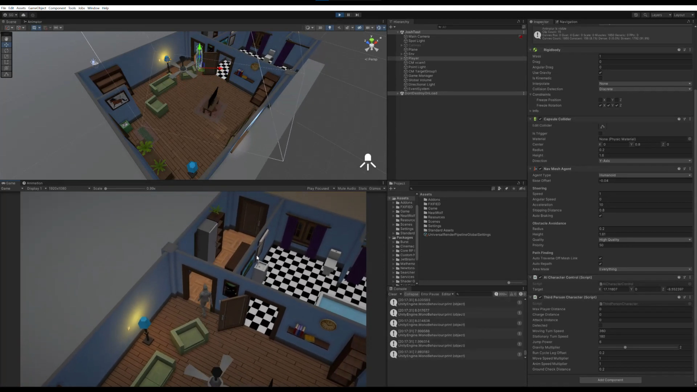

**Figure 7: Exploration in One-Way Ride (WIP)**

> ***Interaction System:*** The interaction system is designed to make the player more aware of the environment by hiding the outlines of interactable objects until the player is within a certain radius and line of sight. This encourages exploration and curiosity, as opposed to other games that make interactable objects too obvious and hand-held. The system also allows the player to initiate dialogues with other characters, inspect objects more closely, know more about objects in the environment or act as a cover for shooting. There are three types of interactables, Inspectable and Scripted, outlined in yellow and Cover in red. Disco Elysium hides interactables until you hover over them while also giving the player an option to make it easier by simply hitting the tab button to outline them. In Hogwarts Legacy, “Revelio” is a spell used to reveal hidden objects, messages, chests, puzzle components and invisible things. It starts to get repetitive as the player needs more information about the world and can cast the spell repeatedly.

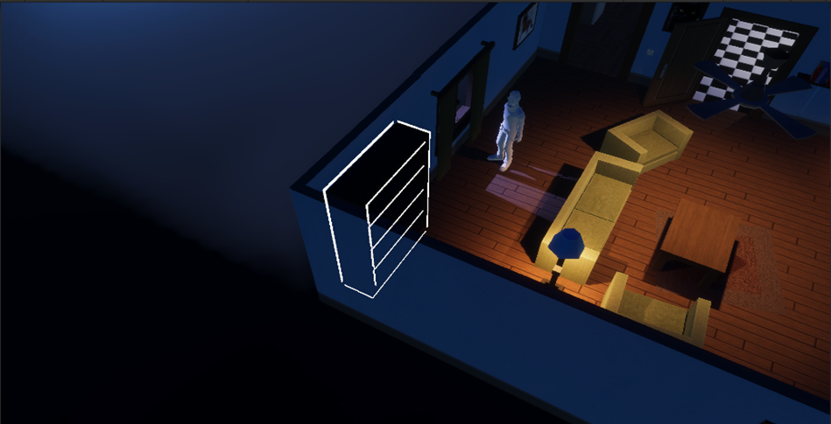

**Figure 8: Interactable Objects are outlined in different colours**

> ***Intelligence System:*** The game uses inspectable and scripted interactables with a hidden intelligence system to provide clues and hints for the story’s progression. The player can interact with various objects in the environment to trigger dialogues that reveal more information about the world and the characters. Some of these interactions are dependent on the timing and sequence of events in the game whereas the story won’t move forward without some.

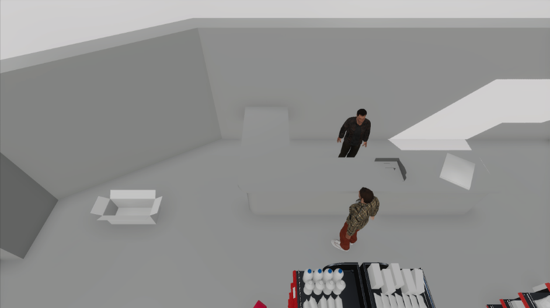

**Figure 9: Interaction is not visible as the player has a low intelligence level.**

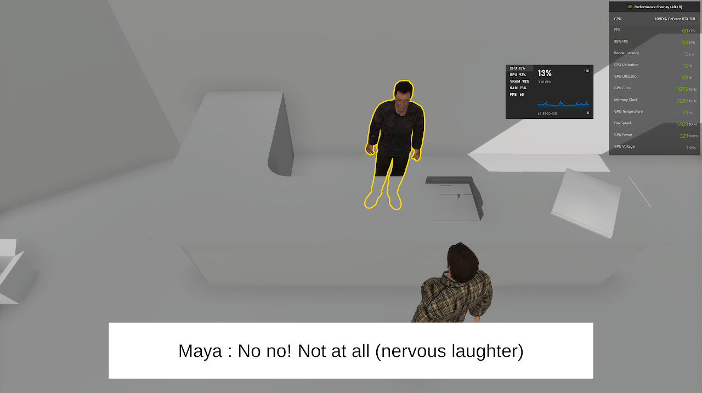

**Figure 10: Player can interact with the Receptionist after gaining information.**

## **3.2 How Chapter-Based Gameplay Enhances Novelty**

> ***Levels of Exploration:*** Exploration is a key mechanic for the players to gain knowledge in the game. Every chapter is an event in Mariano’s past with the first and the last chapters set in the present. It is essential to have multiple floors in buildings such as warehouses and construction sites. Disco Elysium implements different floors and locations with a small loading scene between different levels and locations, which feels continuous despite being separate levels. The game prototype has cutscenes between each chapter as they occur in different years and within the chapter, everything flows naturally with the help of disappearing floors. Which fades out every floor above the player when they are indoors giving a more immersive experience.

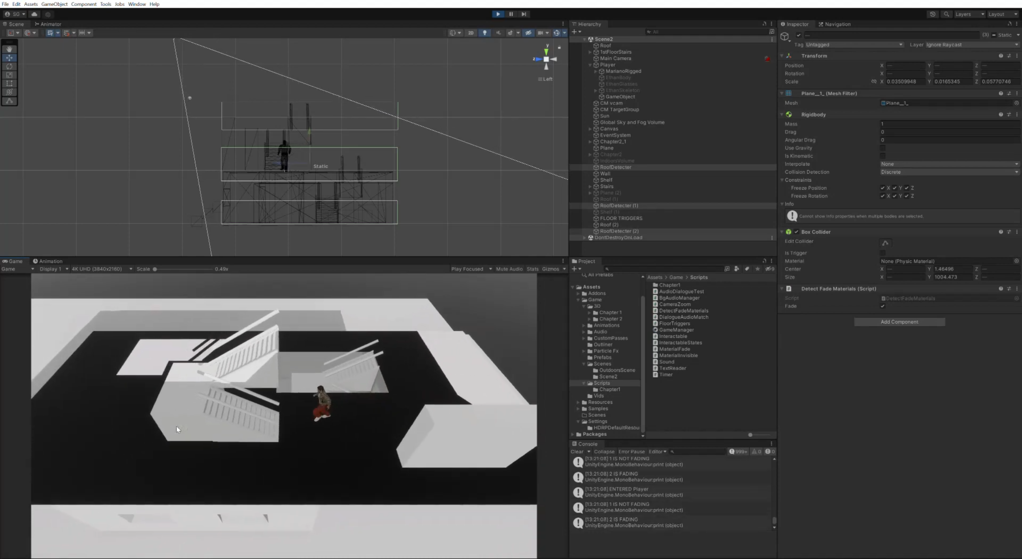

**Figure 11: The multiple level fading system with each floor having their own trigger.**

> ***Stealth, Cover and Gunplay:*** In WRoEF, every character’s story is told in a different way by conveying a character’s emotion through their perspective of the same world. From playing as an owl, to sailing ships in your mind at work, wordplay and many more experiences. Similarly, One-Way Ride tries to use stealth, cover and shooting mechanics according to the story to have dynamic gameplay. The dynamic cover system allows the use of dynamic animations allowing the player to crouch behind the cover which adjusts the crouch height keeping them hidden. This along with the cover-based shooting system allows for a mixed playstyle.

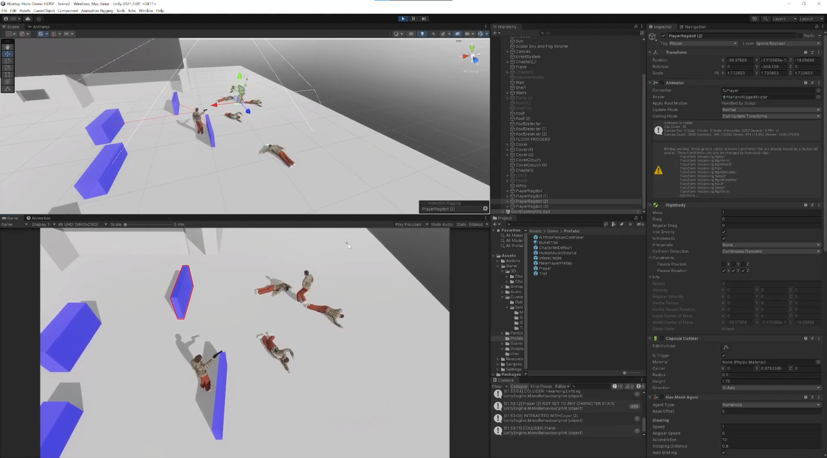

**Figure 12: Shooting enemies from behind cover Interactables.**

## **3.3 Tailoring Player Experience to Prior Interactions within a Fixed Narrative**

> ***Drunk and Health System:*** Disco Elysium has four skills which are: Logic, which allows you to deduce facts to solve problems. Volition keeps your mind in check from impulses and negative emotions. Endurance determines your ability to withstand pain and other physical activities and Perception, which enhances the players understanding of an environment. All these skills affect and changes throughout the gameplay based on interactions and or decisions made during the run by creating branching storylines. In One-Way Ride, there are bottles scattered around the scene and the player can choose to drink from them or not. The drunk and health system are intertwined with the drunk meter which always reduces over time. Choosing to drink increases the drunk meter which in-turn reduces the maximum health the player can have. Drinking results in inaccurate aim during combat but at the same time reduces the damage received from rival gangs. Otherwise, players will have precise aim with more damage from the enemies.

## **3.4 Creating Fail States for Story-Driven Games**

Some games use death as a narrative device that adds realism, drama, and choice to the story. Others use death as a gameplay mechanic that affects the difficulty, progression, and replayability of the game. Death in top-down games can be seen as an expression of the game’s vision and philosophy, as well as an invitation for the player to engage with the game’s world and systems. In Disco Elysium, the player can fail in multiple ways which affect the game differently. There are white checks which you can try again. Red checks, where the player will have to look for another way to solve an issue of accept the consequences. Other fail conditions include when u can’t progress, run out of time or lose all the health or morale. In this case, the game ends with a newspaper article that summarizes their demise and its impact on the world along with multiple other endings.

Baldur’s Gate [19] and Divinity: Original Sin [20] are top-down RPGs that use a party system, where the player can control multiple characters and switch between them. If a character dies, the player can use another character to revive them with a spell, an item, or continue playing with the remaining characters.

In One-Way Ride, there’s an autosave system which saves the objects interacted with and where the player is after important story events. Since the story is about the past of Mariano, failing would mean that it never happened. So, if the player dies in the game, there are a few lines where Mariano tries to recall the actual events as the game still plays in the background and is then reset to the last save point.

**Challenges:**

> While coming up with the idea of multiple levels of exploration, the main challenge was whether the game engine could handle as many objects in the scene and run with a consistent framerate as its going to be a continuous level. The issue was solved by using the occlusion culling in unity to only load and render the objects in the camera frustum.

> One of the main challenges was to balance the difficulty and pacing of each playstyle. Some testers found the shooting and surviving too hard. This affected their enjoyment and immersion in the game experience. Knowing that the shooting and cover had a learning curve, a small tutorial was implemented to fit and flow with the story.

> Since the prototype is a story driven game, coming up with mechanics that would alter player experience proved to be a tough task. It always seemed easy to just have branching dialogues based on player interaction with the NPC’s. But it wouldn’t be feasible along with the time constraint.

> One decision which had to be made earlier on was choosing between the different pipelines in unity. Performance wise, URP is better and can be used to build for mobiles and WebGL. But HDRP support much realistic graphics, volumetric fog, and a wide range of post-processing effects. Since the target platform is only PC and the game needed to look good and have high-fidelity graphics HDRP was the best solution.

> Being an Hons. project and working with a narrative designer, there was a lack of 2D and 3D artist to help bring out the look of the prototype. It was hard to manage both the mechanics and the level in the game engine simultaneously working on both. It felt like the project was lacking even though the mechanics were implemented. Adding to this there was a very limited time to develop the prototype and I had to take up multiple roles to ensure that the project was on track.

# **4. Conclusion**

One-Way Ride, a story-driven 3D-Top-Down hybrid game prototype achieved its main goals of delivering a polished game prototype with multiple genres of playstyles and answering the main design research questions. While it was hard to make some design choices, some decisions had to be made to account in for the limited time and resources. We worked together, with clear roles and responsibilities using GitHub and a Gantt chart to track and organise the development progress. Some learnings from the project and for the future include:

- The importance of keeping a detailed and updated game design document (GDD) that outlines the vision, scope, features, and mechanics of the game.

- The need for frequent communication and feedback among the team members to ensure alignment and collaboration.

- The benefits of using agile methods and tools to plan, execute, and monitor the project activities and deliverables.

- The challenges of creating a hybrid game that combines different genres and play-styles, and how to overcome them by focusing on the core gameplay loop and user experience.

- Conduct more frequent testing within the dev circle to quickly fix problems that arise early on.

Overall, working on the project was a fun and educational experience and I am motivated to convert this prototype into a final product by continuing to work on the rest of the chapters and publish it on a few markets like Steam, itch.io and Epic Games.

# **References**

[1] Bycer, J., 2020. A Study Into Puzzle Design in Video Games. Game Wisdom.

[2] Fernández-Vara, C. (2019) Introduction to game analysis. London: Routledge

[3] Wei, H & Durango, B 2019, Exploring the Role of Narrative Puzzles in Game Storytelling. in Proceedings of the 2019 DiGRA International Conference: Game, Play and the Emerging Ludo-Mix. Digital Games Research Association

[4] GDC (2019) Sparking Curiosity-Driven Exploration Through Narrative in ‘Outer Wilds’. [Video]

[5] Schell, J., 2019. The Art of Game Design: A Book of Lenses. 3rd ed. Boca Raton: CRC Press

[6] Ermi, Laura & Mäyrä, Frans. (2005). Fundamental Components of the Gameplay Experience: Analysing Immersion.. Worlds in Play: Int. Perspectives on Digital Games Research

[7] Bozdog, M., & Galloway, D. (2020). Worlds at Our Fingertips: Reading (in) What Remains of Edith Finch. Games and Culture, 15(7), 789–808. https://doi.org/10.1177/1555412019844631

[8] Riedl, M. O. and Bulitko, V. (2012) “Interactive Narrative: An Intelligent Systems Approach”, AI Magazine, 34(1), p. 67. doi: 10.1609/aimag.v34i1.2449.

[9] Game Maker’s Toolkit (2021) The Power of Invisible Choices [Video]

[10] Remo, C. (2019) Interactive Story Without Challenge Mechanics: The Design of ‘Firewatch’ [Video]

[11] Haggis, M. (2016). Writing ‘Nothing’: Storytelling with Unsaid Words and Unreliable Narrators [Video]

[12] Breslin, J. (2019) Hierarchy of Fail States in Game Design. Available at: https://game-wisdom.com/critical/hierarchy-of-fail-states-game-design

[13] Quantic Dream, 2010. Heavy Rain [Video Game]. Sony Computer Entertainment

[14] Fox, T. (2015) Undertale [Video Game]. Toby Fox

[15] 3909 LLC. (2013) Papers, please [Video Game]. 3909 LLC

[16] Giant Sparrow, 2017. What Remains of Edith Finch [Video Game]. Annapurna Interactive

[17] ZA/UM, 2019. Disco Elysium [Video Game]. ZA/UM.

[18] 2K Games (2016) Mafia Series [Video Game Series]. 2K Games

[19] BioWare (1998) Baldur’s Gate [Video game]. Interplay Entertainment  
[20] Larian Studios (2014) Divinity: Original Sin [Video game]. Larian Studios